HPA Lab:

Before this, start the Docker Desktop:

Go to the terminal:

>> minikube start

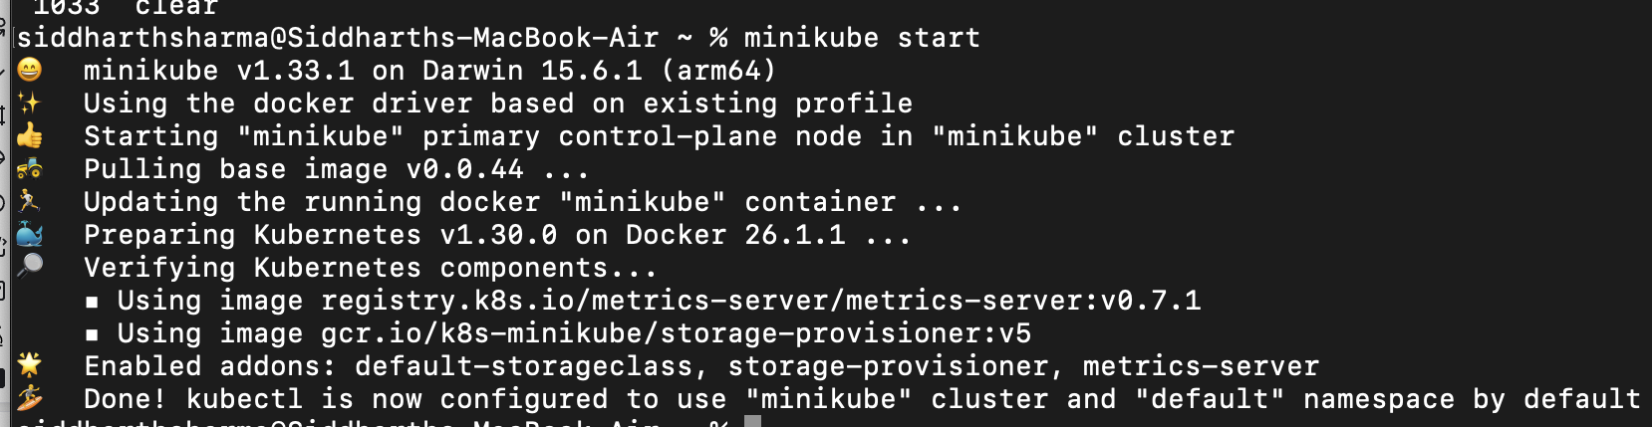

>> minikube status

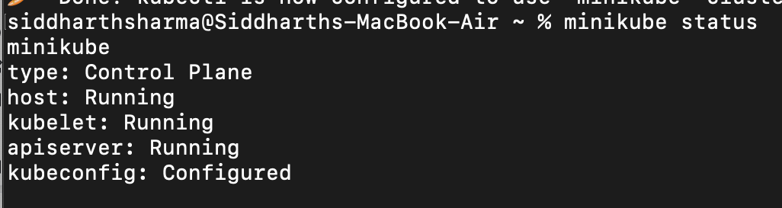

>> minikube addons enable metrics-server

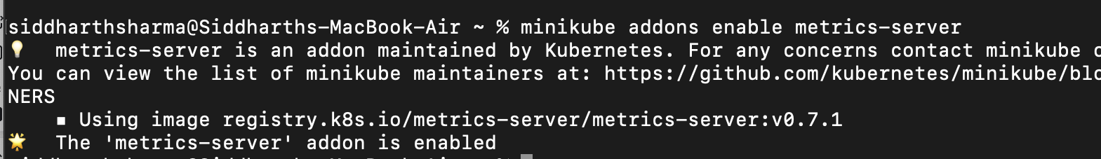

>> kubectl get deployment metrics-server -n kube-system

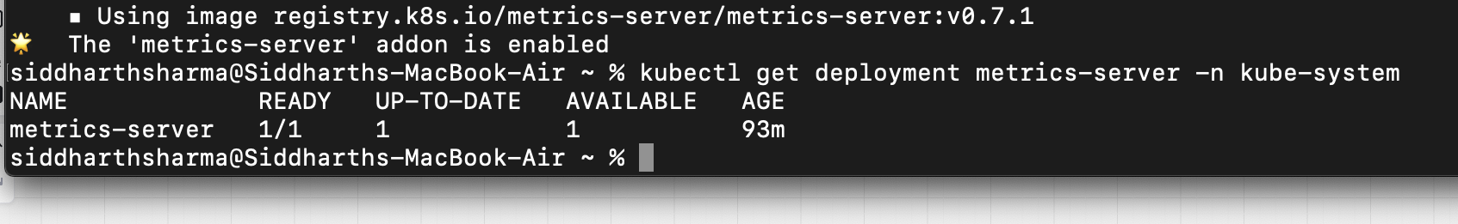

>> nano nginx-deployment.yaml

YAML file for deployment:

apiVersion: apps/v1

kind: Deployment

metadata:

name: nginx-deployment

spec:

replicas: 1

selector:

matchLabels:

app: nginx

template:

metadata:

labels:

app: nginx

spec:

containers:

- name: nginx

image: nginx

resources:

requests:

cpu: 100m

limits:

cpu: 500m

>> kubectl apply -f nginx-deployment.yaml

>> kubectl autoscale deployment nginx-deployment --cpu-percent=50 --min=1 --max=5

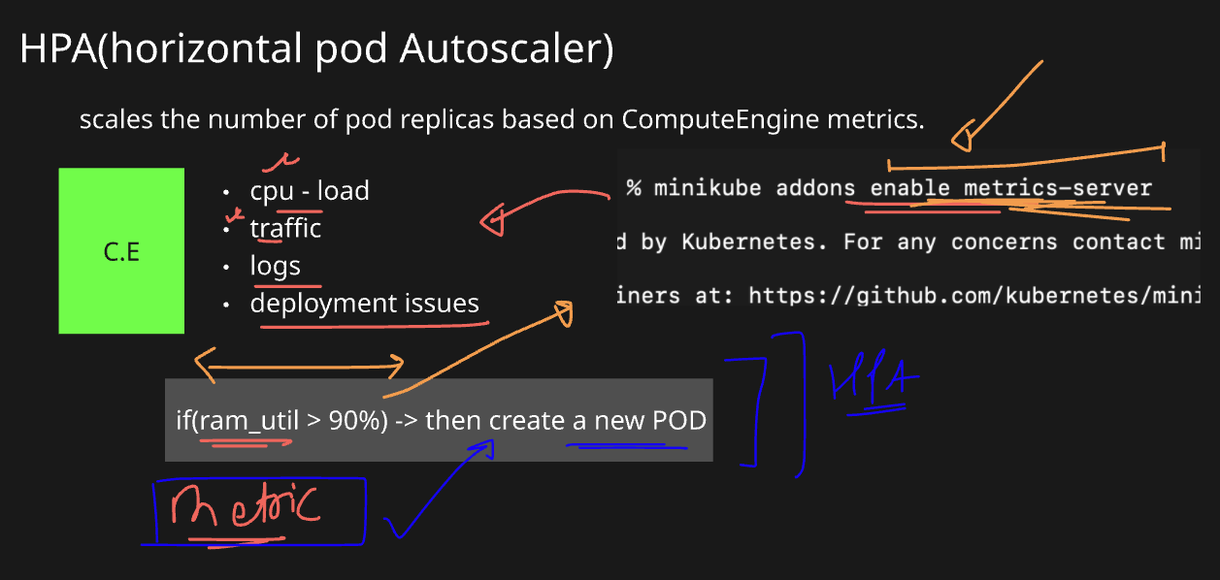

>> kubectl get hpa



>> kubectl expose deployment nginx-deployment --port=80 --target-port=80

>> kubectl delete pod load-generator

>> kubectl run -i --tty load-generator --image=busybox -- /bin/sh

: while true; do wget -q -O- http://nginx-deployment; done

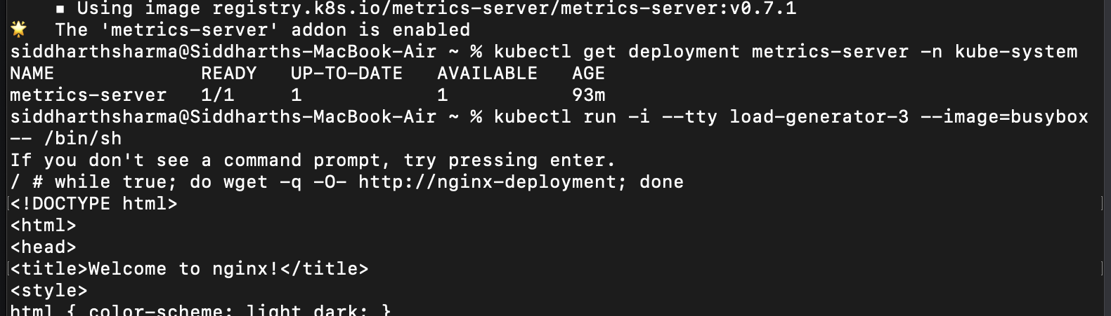

>> kubectl get hpa -w

